Organic Chemistry
How to remember |  | HOMOLYGOUS SERIES | GENERAL FORMULAE |  | HOMOLYGOUS SERIES | GENERAL FORMULAE
 | Carbon No. | Alkanes | C_{n}H_{2n+2} | Alkenes |  | C_{n}H_{2n}
Monkey’s | 1 | Methane | CH₄
Eat  Rhyme | 2 | Ethane | C₂H₆ | Ethene |  | C₂H₄
Peanut | 3 | Propane | C₃H₈ | Propene |  | C₃H₆
Butter | 4 | Butane | C₄H₁₀ | Butene |  | C₄H₈
Pentagon | 5 | Pentane | C₅H₁₂ | Pentene |  | C₅H₁₀
Hexagon  Think Shapes | 6 | Hexane | C₆H₁₄ | Hexene |  | C₆H₁₂
Heptagon | 7 | Heptane | C₇H₁₆ | Heptene |  | C₇H₁₄
Octagon | 8 | Octane | C₈H₁₈ | Octene |  | C₈H₁₆
Nonagon | 9 | Nonane | C₉H₂₀ | Nonene |  | C₉H₁₈
Decagon | 10 | Decane | C₁₀H₂₂ | Decene |  | C₁₀H₂₀

Alkane (saturated) |  | Alkenes (unsaturated) |  | Alkynes (unsaturated)
Structural Formulae | Skeletal Formulae | Structural Formulae | Skeletal Formulae | Structural Formulae | Skeletal Formulae
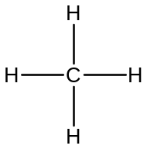

Methane
CH₄
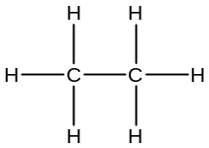  Ethane  CH₃CH₃ | 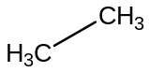  Ethane | 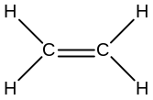  Ethene  CH₂CH₂ |   Ethene | Ethyne  CHCH | Ethyne
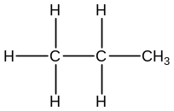  Propane CH₃CH₂CH₃ | 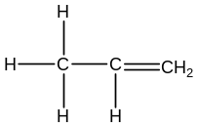  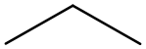  Propane | Propene  CH₃CHCH₂ |   Propene | Propyne  CH₃CCH | Propyne
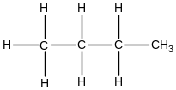  Butane  CH₃CH₂ CH₂ CH₃ | 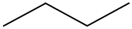  Butane | 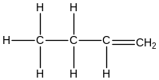  But-1-ene  CH₃CH₃CHCH₂ |   But-1-ene | But-1-yne  CH₃CH₃CCH | But-1-yne

Functional Groups you should be aware of:
Methyl- | Ethyl- | Propyl- | Flouro- | Chloro- | Bromo- | Iodo-
-CH₃ | -CH₂CH₃ | -CH₂CH₂CH₃ | -F | -Cl | -Br | -I
Functional Groups on Carbon chains to change the ending of the carbon chain:
Functional Group | Alkene | Alkynes | Alcohol | Carboxylic acid | Aldehyde | Ketone | Amine | Amide | Ester
General Formula | C=C | CΞC | -OH | -COOH | -CHO | -COC- | -NH₂ | -CONH₂ | -COOC-
Naming | -ene | -yne | -anol | -anoic acid | -anal | -anone | anamine | -amide | anoate
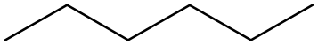
Nomenclature and Process Tips;
- We would then write longer chains such as hexane C₆H₁₄ or CH₃(CH₂)₄CH₃
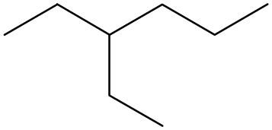
- We number the carbons on the longest chain available.
1
2
3
4
5
6

- The position of the functional group changes the number in the middle of the name. Of the compound.
Please notice the transition here letters to number there is a dash! & Vice Versa

This is But-2-ene because the functional group is on carbon 2 in the chain.

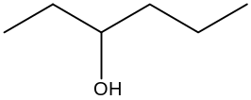
This is Hexan-3-ol for the same reason but also it must be the smallest carbon number, for example you cannot have hex-4-ene.

Please notice the transition here number to number there is a comma
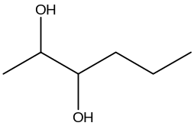
This is called Hexan-2,3-diol as it has two Alcohol groups on two different carbons corresponding with their carbon number position.

- Prefixes of di-, tri-, tetra- are used for multiple functional groups.
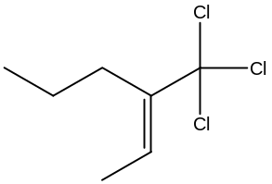
Footnote: Functional groups are above this you must know are coming up!
- The longest chain must also contain all the functional groups.
This is called 1,1,1-trichloro-2-propylbut-2-ene.
The Pentane chain didn’t contain the Alkene group.
- The last tip involves a simple and yet surprisingly confusing concept. The Alphabet. You need to make sure you put them all in alphabetical order with the corresponding carbon number.
This is called 1,2-dibromo-1,1,3-dichloro-2-ethyl-4-methylHex-3-ene. It’s a big one but notice how all the functional groups start in the correct alphabetical order (when you do it you don’t have to
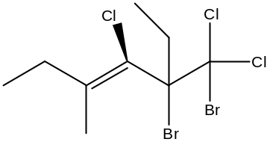
make it bold).

Alicyclic and Aromatic Compounds are a different story. There are many dimensions to this and should be avoided until the previous steps have been mastered. These can range from Sugars, cycloalkanes, cycloalkenes to Benzenes, styrene’s and even polymers. Items in this course are highlighted bold.

- Geometric Isomerism
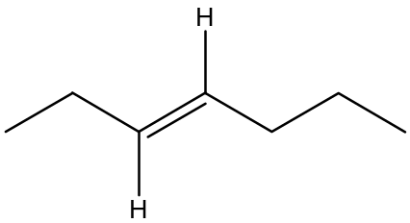
This only ever happens around a double bond. Now we need to look at the hydrocarbon chain and bend it so it looks like an H shape. Eg.
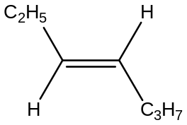
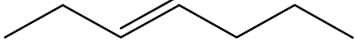

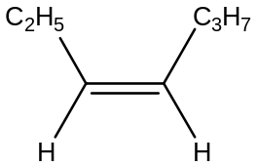
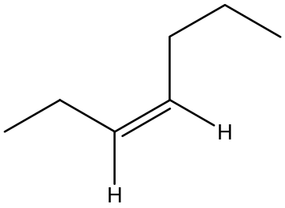
Now we can tell this is a trans-isomer of Hept-3-ene. One with nearly exactly the same formulae (transmit a signal across a wire)
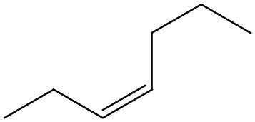

This is the cis-isomer of Hept-3-ene. You can predict by looking at this that this isomer may be in fact more volatile than the other due to its shape and less contact with surrounding molecules. (to remember cis ... sisters are always on the same side of an argument)
Extension:
Properties between isomers change properties of that substance quite easily and it was a cause of an unsuspecting chemist a simple isometric error led to a catastrophe in the distribution of the morning sickness drug Thalidomide. Find out what happened. There are some horrifying pictures!!
- Alicyclic and Aromaticity
Alicyclic compounds literally are a hydrocarbon in a complete cycle.
Name | Cyclohexane | Cyclohexene | Cyclohexyne
Structural Formula | 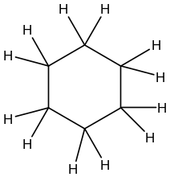 | 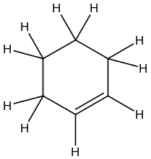 | 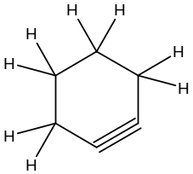
Skeletal Formula | 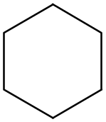 | 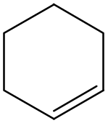 | 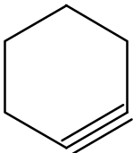
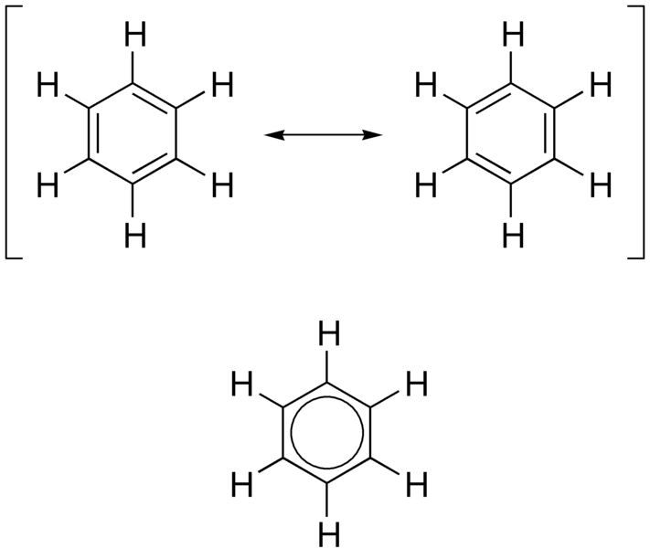
- Aromatic Compounds are similar but contain some form of electron arrangement called conjugation. A good exam.ple of this is Benzene. Where electrons are continually moving and are delocalised. This is denoted with a circle.

REACTIONS OF ORGANIC COMPOUNDS
Electrophilic Addition a.k.a ADDITION
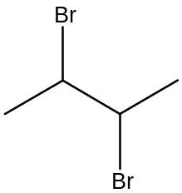
Occurs in two types of reaction where halogens are ADDED to an unsaturated hydrocarbon.

+ Br₂ 
NOW FOR THE GOOD BIT... TO RELATE THIS TO THE REAL WORLD THIS IS THE VERY BEGINNING OF WHERE SYNTHESIS OF MEDICINES BEGINS OR EVEN INSECTICIDES, OIL REFINERY AND CHEMICAL ANALYSIS IN FORENSICS!!!

(bromine takes the electron
from the double bond in the Alkene)
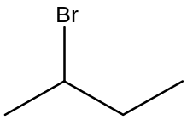
+ HBr 
Electrophilic Substitution a.k.a SUBSTITUTION
Occurs when an Alkane or Benzene SUBSTITUTES one of its hydrogen atoms for a Halogen
uv
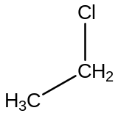
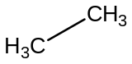
Cl-Cl +  HCl +

bromine is ripped apart by light and takes the electron
from the double bond in the Alkene and is done in steps therefore a slow reaction.
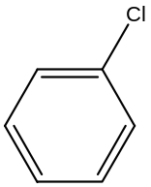
It creates a species called a radical; denoted Cl.
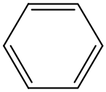
uv
Cl-Cl +  HCl +

FeCl₄⁻ +  HCl +

Combustion

Basically burning these hydrocarbons with oxygen to make carbon dioxide and water. This is better done in plenty of oxygen for complete combustion, this is why alcohols burn cleaner. Incomplete combustion occurs in the lack of oxygen and as a result breaks and forms fewer bonds releasing less energy and carbon monoxide.

You can look forward to the following in Year 12
- Cracking ← introduced in Q5.
- Polymerisation
- Making proteins
- Nucleophilic Addition
- Nucleophilic Substitution and more ☺

